ASSIGNMENT 10

DATA230 – DATA VISUALIZATION

Submitted by : Gayathri Sundareshwar 12/05/2022

**Table Of Contents**

1. Introduction 3

2. Dataset Description 3

3. Data Pre-processing 3

3.1 Handling the Null values 4

3.2 Handling the Redundancy 5

3.3 Verifying Datatypes 6

4. Tableau Visualization Overview 7

4.1 Home Page 8

4.2 Customer Information 8

4.3 Regional Information 9

4.4 Order Statistics 10

4.5 Sales Statistics 11

4.6 Gender Statistics 12

5. Graphic Design Principles 13

5.1 Text and Typography 14

5.2 Color Theory and Color Use 14

5.3 Layout and White Space 14

5.4 Consistency and Design Vocabulary 14

5.5 Visual Encoding 15

6. Gestalt Principles and Cognitive Modeling 15

6.1 Top-Down Processing 15

6.2 Proximity 17

6.3 Closure 18

6.4 Figure and Ground 18

6.5 Continuity 19

7. Interactions 20

7.1 Tooltips / Hover Help 20

7.2 Zooming and Scaling 21

7.3 Drill Down 21

7.4 Selection 23

7.5 Overlays 25

7.6 Storytelling 25

8. User Interface Principles 27

9. Overall Effectiveness 27

10. Summary 28

# Introduction

The project help visualize an assorted set of statistical representations of data categorized into various sectors based on a few primarily influential features. The dataset chosen here is a representation of US Online Sales. The visualizations created are chosen carefully considering categorization, gestalt principles, cognitive modeling and top-tier interactions. Detailed descriptions regarding the dataset and the various visualizations created will be discussed in the forthcoming sections.

# Dataset Description

The dataset chosen here consists of records related to US Online Sales. Statically speaking, the dataset consists of 280k+ records, each containing 36 features. There are 17 numerical fields, while the rest are categorical. Figure 1 depicts the fields present in the dataset.

**Figure 1**

*Features list from USOnlineSales Dataset*

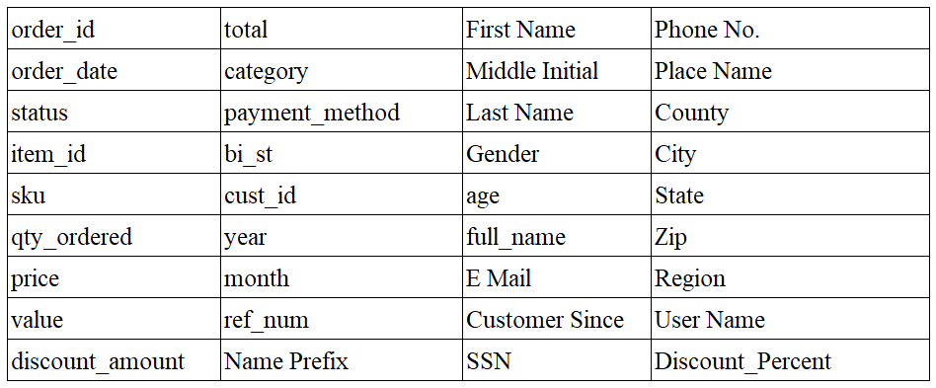

# Data Pre-processing

Data can be a significant factor that can be persuasive while making business decisions. An adequately sourced collection of information regarding the topic can come in handy when identifying the patterns, leading to business decisions that possibly can impact future performance. The collected data may sometimes be inaccurate, missing, redundant, or inconsistent, leading to incorrect prediction in the modeling phase and, thus, the inability to achieve the project's goal. Therefore, data cleaning involves reviewing the data to remove or update any dirty ones, thus ensuring a better quality of the data used in the subsequent phases. Data pre-processing involves a wide range of procedures to help eliminate discrepancies within the extracted raw data. Hence, an intensive pre-processing process was performed with utmost attention, which will be explained in the following section.

## 3.1 Handling the Null values

The first step of pre-processing is checking for the presence of null values in the dataset and handling them. Figure 2 depicts the null records present in the dataset.

**Figure 2**

*Count of Null valued fields in each feature.*

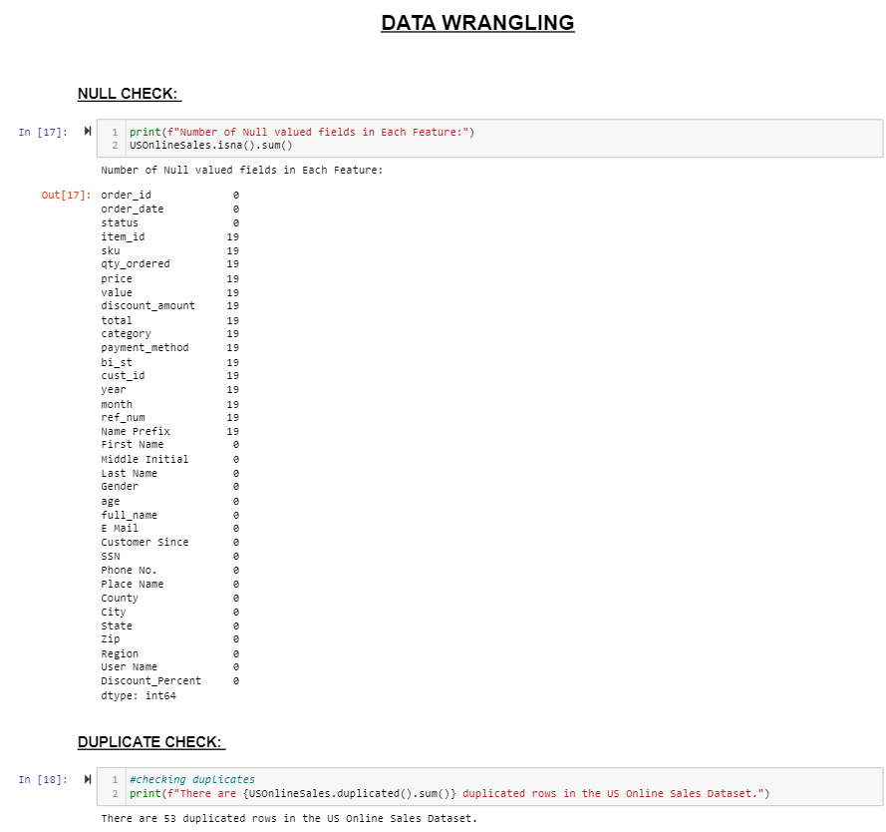

There are multiple ways to handle the nulls, such as replacing them with the mean, removing the feature if more than 70% is null, and deleting the row. The method chosen here was the removal of the records containing the nulls since the number of records with null values was only 19 and thus less significant. Eliminating the records will not offset the other features' statistics, so elimination was chosen. Figure 3 depicts the handling process along with the count of records before and after handling.

**Figure 3**

*Elimination of Null records*

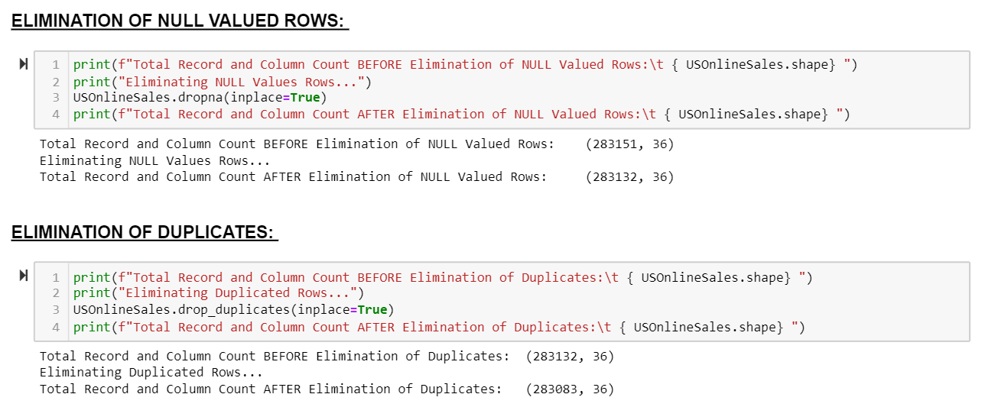

## ***3.2 Handling the Redundancy***

The presence of duplicate records is familiar in most of the datasets; whether to retain the duplicated records or eliminate them is purely based on the kind of data being handled. Hence it is first necessary to check for the presence of redundancy. Figure 4 depicts the total duplicates present in the dataset.

**Figure 4**

*Checking for Duplicates*

Duplicate check shows that 53 duplicated records are present which will be dealt with as needed.

Here, elimination was deemed the superior approach for this specific dataset, and hence the duplicated records were eliminated from the dataset. Figure 5 depicts the elimination of duplicated records and the count of records before and after handling.

**Figure 5**

*Elimination of Duplicated Records*

## 3.3 Verifying Datatypes

The records need to have the proper datatypes assigned; hence it is necessary to assign relevant types. Figure 6 shows the datatypes assigned to the records.

**Figure 6**

*Datatypes Assigned*

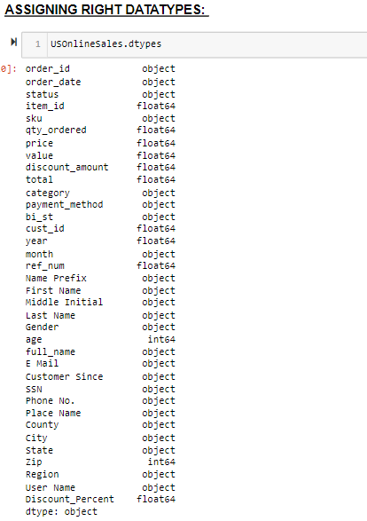

The cleansed dataset returned after various preprocessing steps ensures that the dataset is now clean and can be passed on to the visualization phase where proper insight can be attained. Figure 7 below depicts the total records present after the various pre-processing stages. These records were them imported and passed as input into tableau to create visualizations.

**Figure 7**

*Count of records after cleansing*

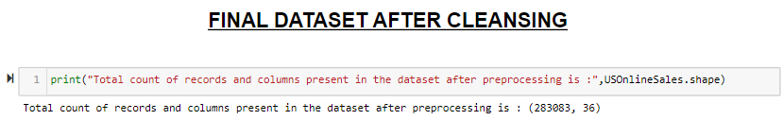

# Tableau Visualization Overview

The cleaned dataset was passed on to tableau, and various visualization depicting the statistics were created, which will be explained in detail in the following section. To provide a preface, a home page was created depicting the buttons with links to various dashboards containing visualizations. An overview of various dashboards and visualizations created in this project will be given below.

The architecture of how this project was carried out contains six major pages listed below,

* Home Page,
* Customer Information,
* Regional Information,
* Order Statistics,
* Sales Statistics and
* Gender Statistics

Each page contains various visualizations grouped to create a cohesive story. Each visualization help understand the data better and enables easy readability for the users.

## 4.1 Home Page

The home page contains the link to the other five pages created using buttons. A click on the link will traverse to the respective sheets. Buttons were used with enabled links to enable this interaction. The home page contains an image carefully chosen considering the topic and aesthetics. The title, 'United States - Sales Statistics,' was added to the home page. Figure 8 displays the created home page.

**Figure 8**

*Home Page*



## 4.2 Customer Information

The first linked dashboard from the home page is 'Customer Information.' The charts present in this dashboard are:

1. Total Customers per State - A Geo-Spatial Map,
2. Top 10 Categories with Highest Customers - Bar Chart
3. Customer Distribution Per Region based on Year - Line Chart

Various visualizations depicting the information related to the customer are displayed here. The dashboard also contains a back button which, when clicked, takes back to the main page. The geospatial map is equipped with a ‘Use as Filter’ interaction, which can help drill down to state-level information of other charts. This can be an example of Cognitive modeling respecting the gestalt principle. Figure 9 displays the ‘Customer Information’ chart visualization.

**Figure 9**

*Customer Information Dashboard*

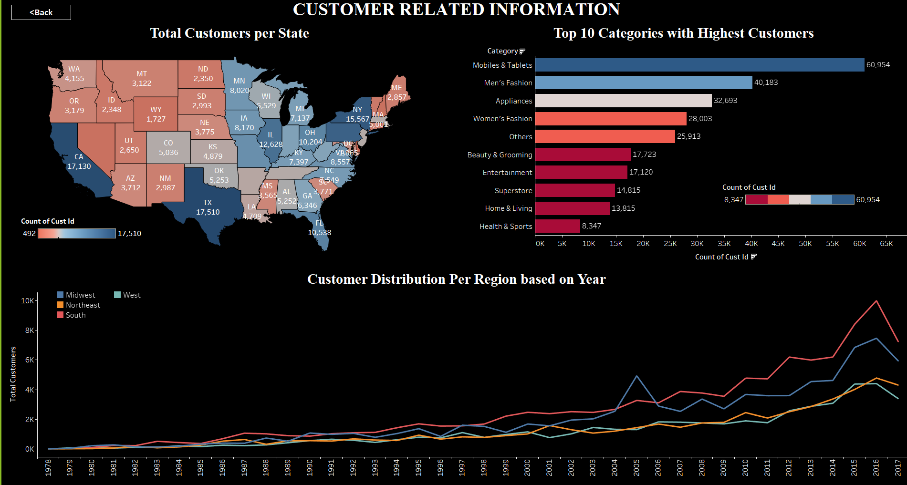

## 4.3 Regional Information

The second linked dashboard from the home page is 'Regional Information.' Various visualizations depicting the information related to the regional boundaries are displayed here. The charts present in this dashboard are:

1. Total Orders per State - A Geo-Spatial Map,
2. Total Orders per Region over a Period – Stacked Area Chart
3. Customer Count per Region - Bar Chart

Various visualizations depicting the information related to the regional boundaries are displayed here. The dashboard also contains a back button which, when clicked, takes back to the main page. The geospatial map is equipped with a ‘Use as Filter’ interaction, which can help drill down to state-level information of other charts. This also can be an example of Cognitive modeling respecting the gestalt principle—figure 10 displays the ‘Customer Information’ chart visualization.

**Figure 10**

*Regional Information Dashboard*

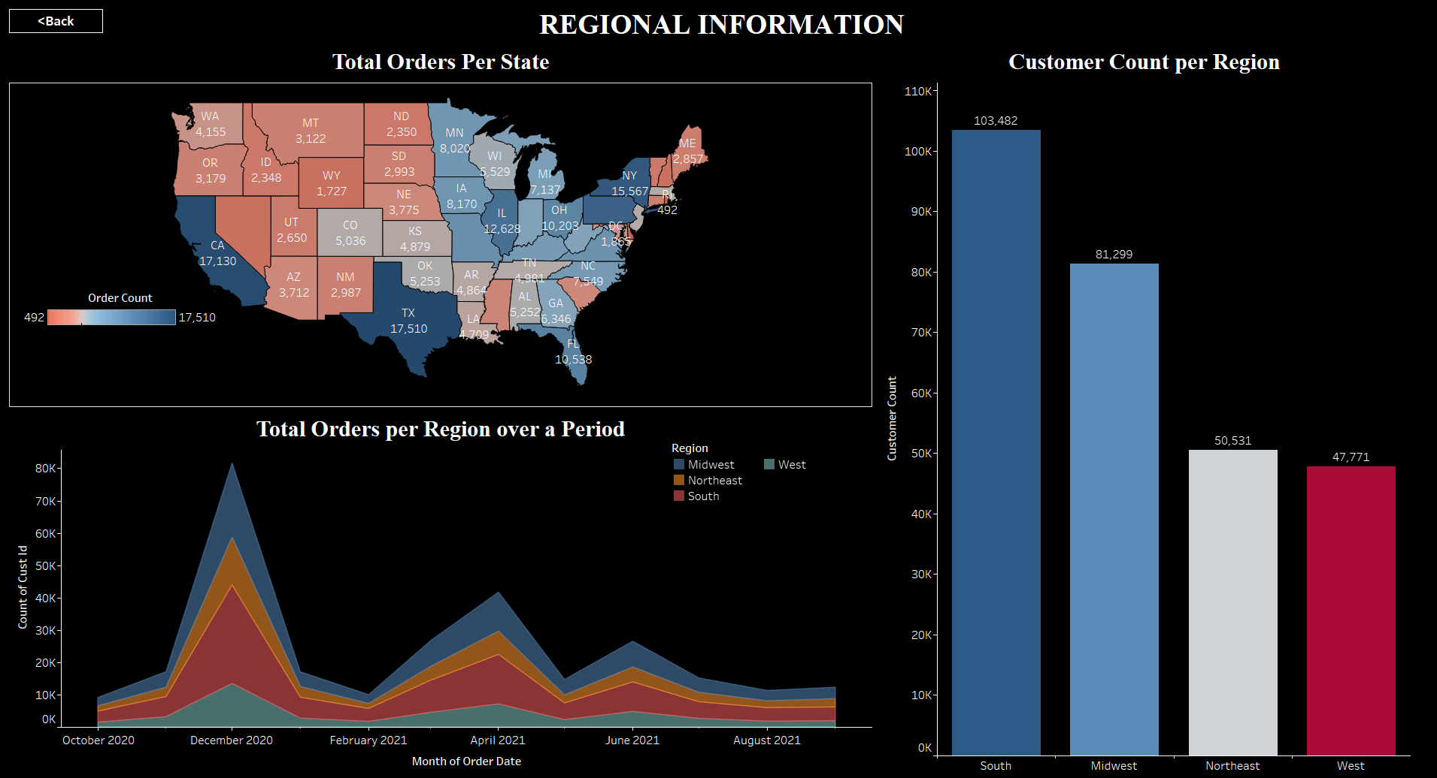

## 4.4 Order Statistics

The third linked dashboard from the home page is 'Order Statistics.' The visualizations in this dashboard depict the information related to the order statistics, such as distribution based on payments. The dashboard also contains a back button which, when clicked, takes back to the main page. The packed bubbles chart is equipped with a 'Use as Filter' interaction, which can help drill down to information from other charts. This can be an example of Cognitive modeling respecting the gestalt principle. Figure 11 displays the 'Order Statistics’ chart visualization. The charts present in this dashboard are:

1. Distribution of Orders by Payment Methods - A Packed Bubbles Chart,
2. 10 States with Highest Order Count - Table
3. 10 States with Lowest Order Count - Table
4. Top 5 Status based on Order Count - Bar Chart

**Figure 11**

*Order Statistics Dashboard*

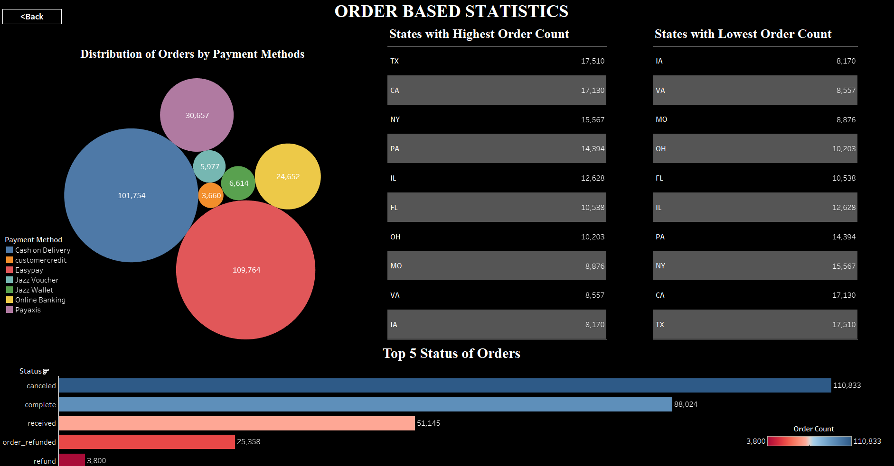

## 4.5 Sales Statistics

The fourth linked dashboard from the home page is related to 'Sales Statistics.' Various visualizations depicting the information related to the sales volume, profit, discount, and quantity are displayed here. The dashboard also contains a back button which, when clicked, takes back to the main page. The packed bubbles chart is equipped with a 'Use as Filter' interaction, which can help drill down to information from other charts This can be an example of Cognitive modeling respecting the gestalt principle. Figure 12 displays the 'Order Statistics’ chart visualization. The timeseries chart also contains an annotation depicting the peak point. The charts present in this dashboard are:

1. Total Sales per State - A Geo-Spatial Map,
2. Yearly Order Growth per Region - Bar Chart
3. Trend of Recorded Sales Amount - Time Series Line Chart
4. Measure's section depicting total order, quantity, sales information - table

**Figure 12**

*Sales Statistics Dashboard*

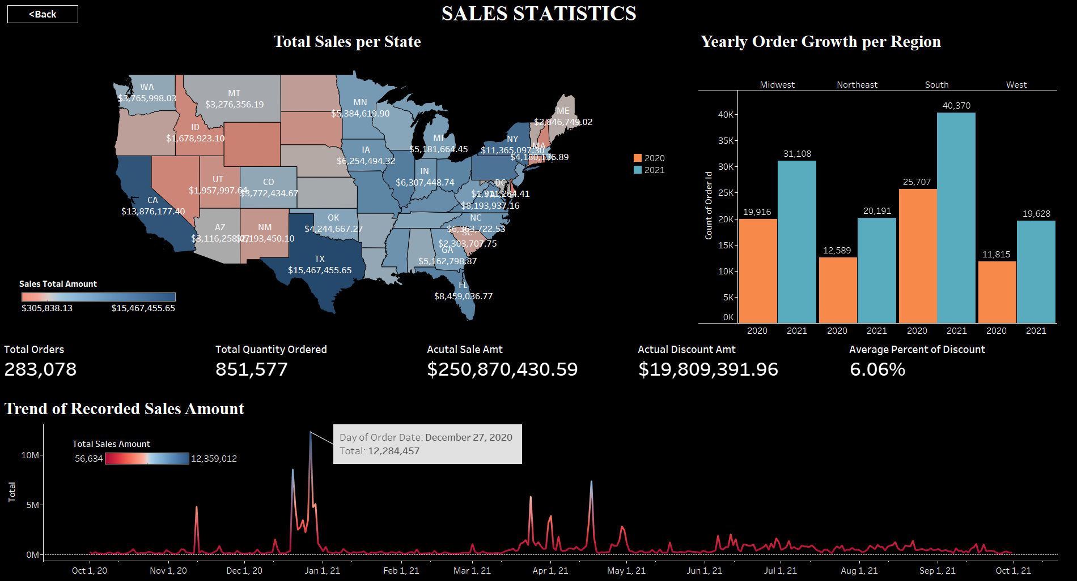

## 4.6 Gender Statistics

The last dashboard linked from the home page is related to ' Gender Statistics.' Various visualizations depicting the information that can help understand the gender-based statistical values are added to this dashboard. The dashboard also contains a back button which, when clicked, takes back to the main page. The pie is equipped with a 'Use as Filter' interaction, which can help drill down to information from other charts and can be helpful when it is needed to segregate gender-based statistics. This can be an example of Cognitive modeling respecting the gestalt principle. Figure 13 displays the 'Gender Statistics' chart visualization. The charts present in this dashboard are:

1. Distribution of Orders by Gender - A pie chart,
2. Category Wise total quantity, price, discount, and actual sales - Table
3. Customer Distribution based on Year - Line Chart
4. Orders Per Payment Method - Bar Chart

**Figure 13**

*Gender Statistics Dashboard*

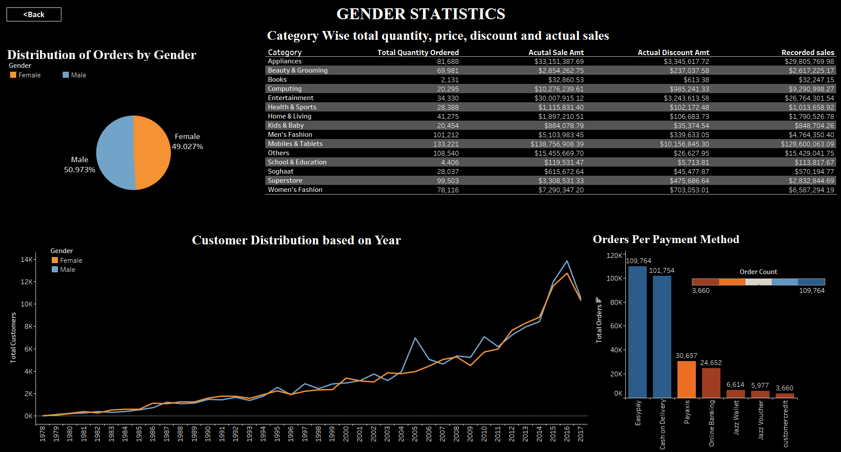

# Graphic Design Principles

Following the graphic design principles help in exceptional visualizations inducing better readability and optimizing the usage of black spaces. Various design principles that were adhered to while developing the project are discussed below,

## 5.1 Text and Typography

Each of the dashboards created adheres to the text and typographic principles, such as the dashboard title font size and stylistic customizations, followed by the inner sub-headings for each chart and its individual stylistic choices, such as font size and font type. The dashboard title font size was set to 22, followed by the inner headings at size 16. Figures 9, 10, 11, 12 and 13 depict the dashboards adhering to this principle.

## 5.2 Color Theory and Color Use

Color theory and color usage principles, such as contrast and the comfort of the visually impaired, were considered. The dark background contrasted with the light and vibrant choices for the charts look both aesthetically pleasing and promotes easier readability. Figures 9, 10, 11, 12 and 13 depict the dashboards adhering to this principle.

## 5.3 Layout and White Space

The dashboards were not crowded, with too much information at once. The layout of the dashboards was maintained to allow between 3 to 4 visualizations at maximum, enabling easier readability. The dashboards also promote proper white spaces, which are aesthetically pleasing. Figures 9, 10, 11, 12, and 13 depict the dashboards adhering to this principle. The presence of blacks emphasizes the areas of the charts filled with information. Too much crowding can work adversely and eliminate the reason behind the creation of visualizations.

## 5.4 Consistency and Design Vocabulary

Consistency was maintained while formulating the various dashboards and the vocabulary used was optimized to be short and precise while not compromising on the quality of information that is intended to be sent to the user. This can be observed all throughout the various dashboards that were created. Figure 9, 10, 11, 12 and 13 depict the dashboards adhering to this principle.

## 5.5 Visual Encoding

In addition to the points mentioned above, visual encoding is implemented to emphasize information.Figure 14 highlights the bar and name on Y-Axis while the other items are subdued automatically. Thus, it emphasizes information based on the category type ‘others’ which was selected.

**Figure 14**

*Example depicting visual encoding*

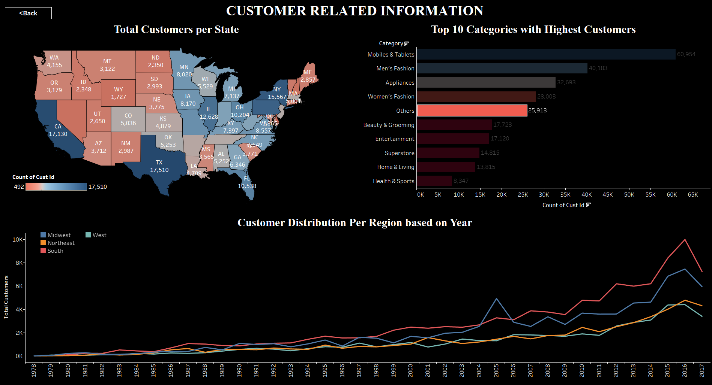

# Gestalt Principles and Cognitive Modeling

## 6.1 Top-Down Processing

The overall visualizations are created to follow a particular pattern, which can be due to the choice of cognitive modeling being top-down processing.

Figure 15 depicts the top level of the cognitive model before opting for any drill down. The other charts of the dashboard depict information encapsulating all the charts. Figure 16 depicts the information after choosing the state of Texas. The other charts are drilled down to represent the information from that specific state only. It can be depicted back to its original state by clicking anywhere outside the depicted states.

**Figure 15**

*Sample of Top-Down Processing – Part1 – Depicting Overall view*

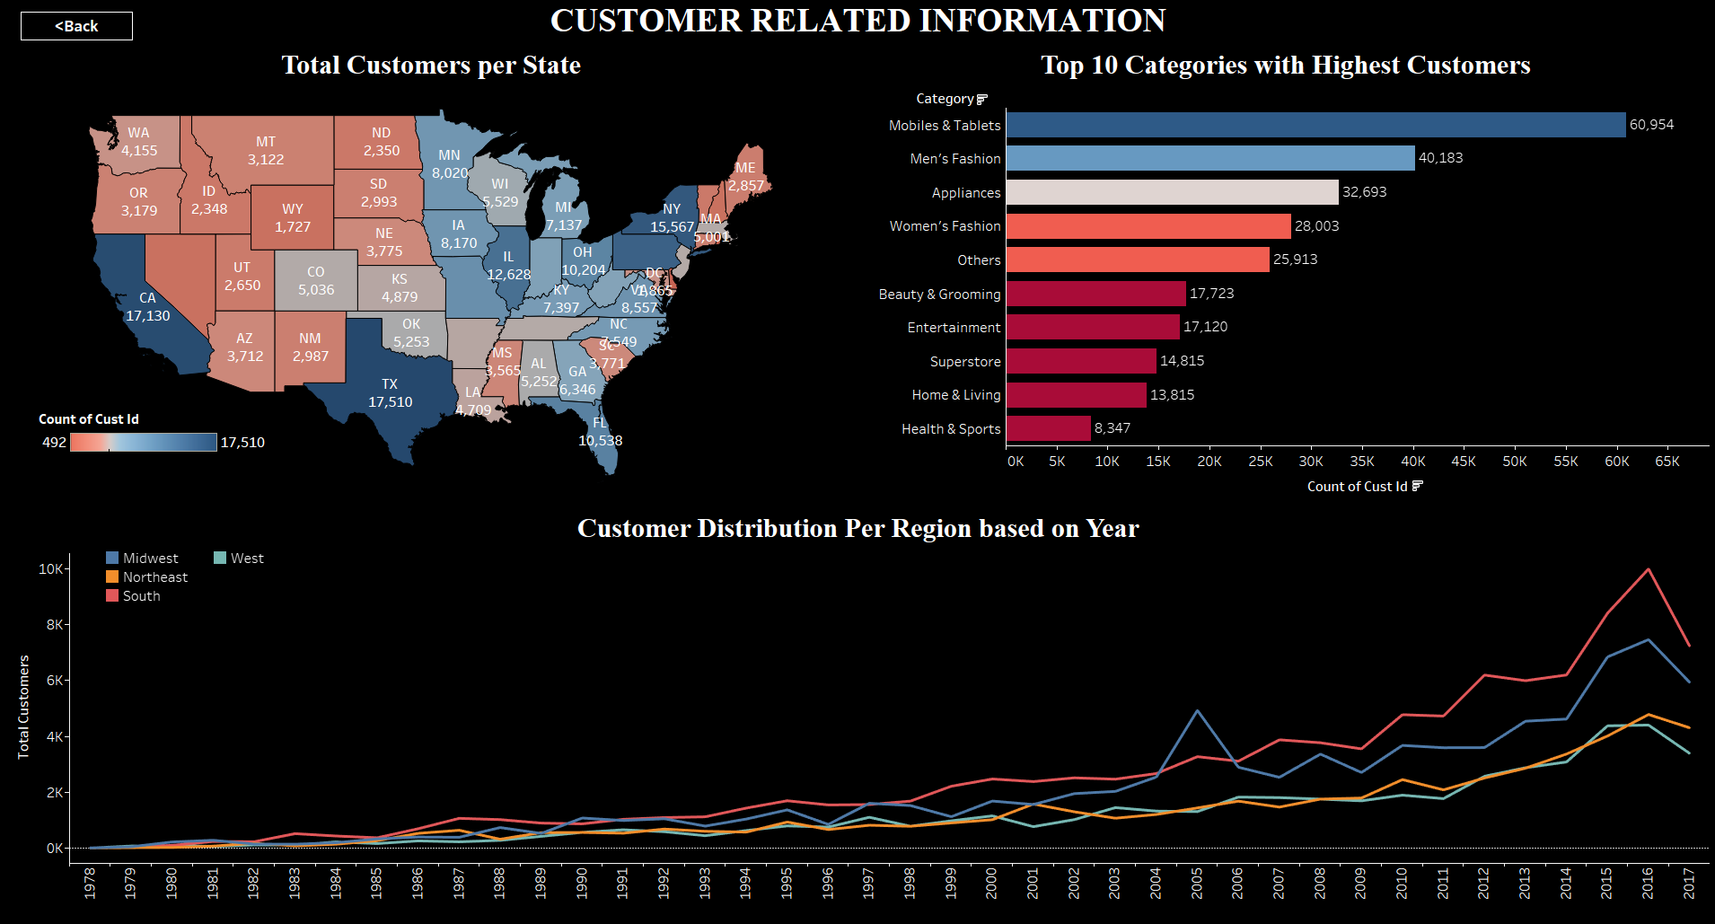

**Figure 16**

*Sample of Top-Down Processing – Part2 – Depicting drilled down view*

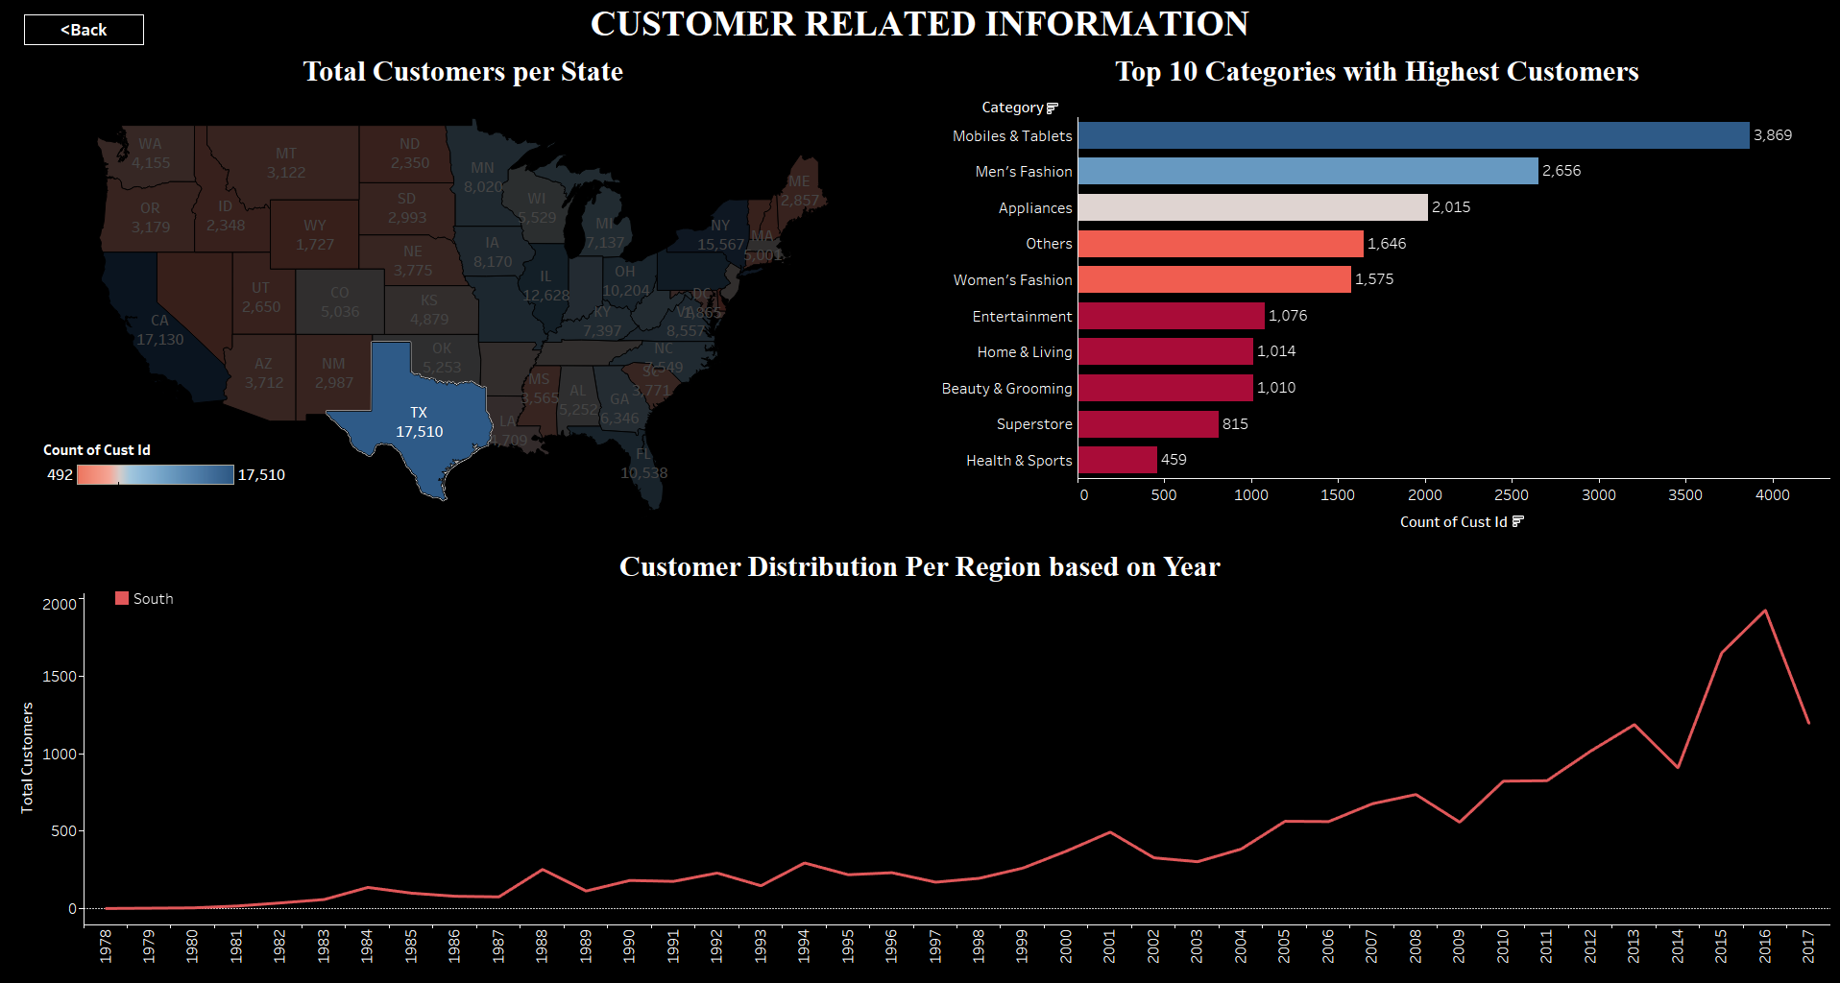

The generalized nature of all the created dashboards is disrupted by equipping a chosen visualization with the filtering option. That specific visualization can help users to drill down and look into information of the user's choice which can also be reverted to original state by allowing the deselection option.

Following the cognitive modeling, the gestalt principles that were adhered to while working on this project will be discussed in this section.

## 6.2 Proximity

A graphical element being close to another graphical element is a strong indication of proximity. When certain elements in visualization are grouped together, the user will recognize that as a single entity and understand that it is distinct when compared to everything else that is on the screen. An example of proximity is explained in the Figure 17 below,

**Figure 17**

*Example of Proximity*

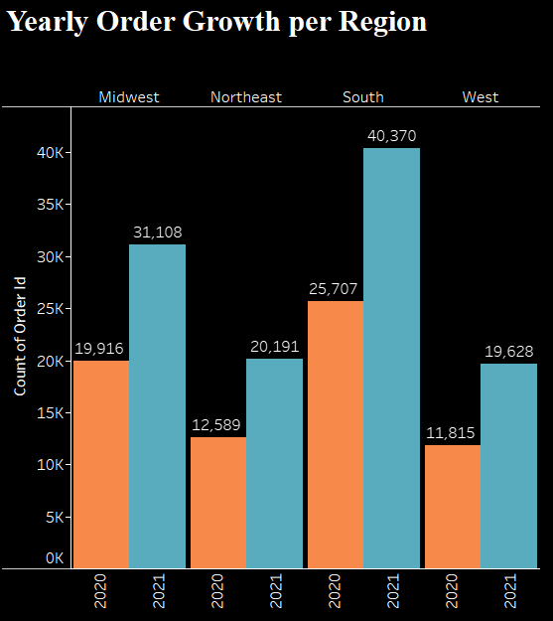

Figure 17 shows that the bar chart is split by regions and the proximity principle is adhered by grouping the regional data into yearly groups. The color distinction between the years and the closeness makes it easier to compare the order growth yearly on that specific region. This is an example of the proximity principle.

## 6.3 Closure

The principle called closure explains the complex arrangement when there is an incomplete link or missing data, the user will try to look for the presence of a recognizable pattern. It is a phenomenon where the eyes try to fill in the link that is missing so that a full picture of the visualization can be obtained. Figure18 below demonstrates an instance of the principle. As we can see in the line chart, there are four lines that are fully linked without any break in the middle.

**Figure 18**

*Example of Closure*

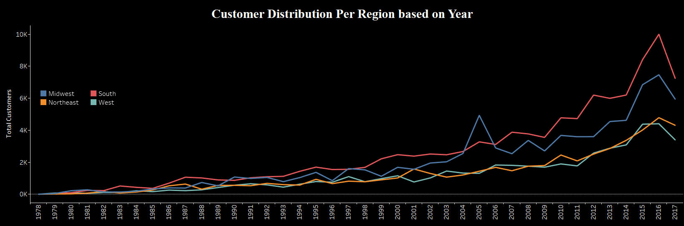

## 6.4 Figure and Ground

Figure and Ground can be explained as the scenario when certain areas of the visualization are made to stand out better than the other areas. The area that stands out can be called a “Figure” and the area that is muted out can be called the “Ground” as in the Background. The figure and Ground principle aids in emphasizing certain elements in the visualization to be more prominent for perceptions than the other parts. Figures 19 demonstrate this property exceptionally well as certain regions are highlighted whereas the other areas are muted out to match the background. This helps in increasing the probability of gathering attention to the highlighted regions exponentially higher. The state of Utah highlighted can be considered as the figure part and the muted states can now be considered as Ground.

**Figure 19**

*Example of Figure and Ground*

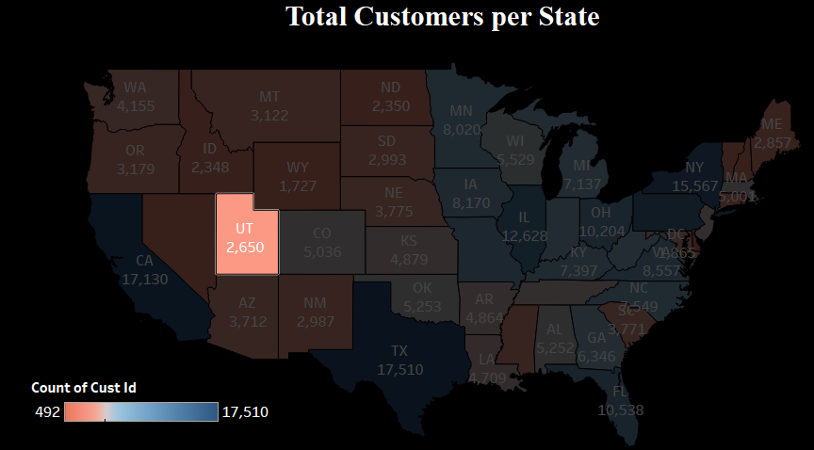

## 6.5 Continuity

The principle of Continuity state that elements that are arranged in an ordered smooth flowing manner are easier to perceive than when it is unordered. Figures 20 demonstrate the continuity principle the best. In the figure we shall see that the bars are ordered from tallest to smallest. This makes it easier to understand the flow of the categorized items in the respective order.

**Figure 20**

*Example of Continuity*

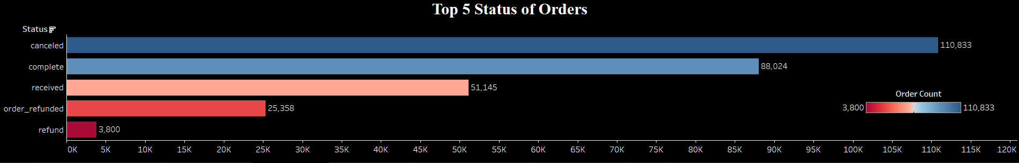

# Interactions

Including interactions within the dashboard or traversing from one dashboard to another can help enhance accessibility. It can assist the users working at ground level to the opposite end of the spectrum. Some of the interactions that were utilized in this project are discussed in this section below,

## 7.1 Tooltips / Hover Help

Tooltips and Hover were enabled for all the dashboards in this project. This helps the user to get data about a specific element by just hovering on top of the specified region. Figure 20 depicts a hover action displaying the characteristics of the specified point in the line chart. The value represented during the hover action by the tool tip can be customized as per the requirement and here the hover action is configured to display the region, year and the count of customers.

**Figure 21**

*Example of Tooltip/Hover*

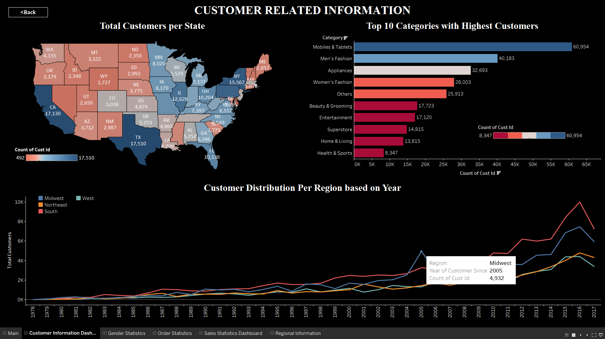

## 7.2 Zooming and Scaling

Zooming and scaling were enabled in all the geo-spatial map so that it is made possible for the users to zoom in and out of the necessary regions. Scaling also helps the users to either view the overall or specific required values alone. Figure 22 shows the zooming enabled geo-spatial map.

**Figure 22**

*Sample Geo-spatial with Zooming and Scaling Enabled*

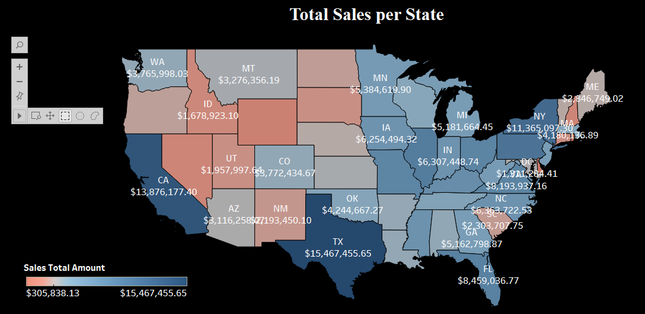

## 7.3 Drill Down

The drill-down part was previously explained in detail when looking into the top-down processing depicted in cognitive modeling. The same thing can attest to the usage of drill-down in interactions. For instance, the figures 23 below represent the statistics shown in the visualizations before applying drill-down transactions. Figure 24 depicts how the values change in the other visualizations when drill-down is used to select one state alone from the geospatial map. The dashboard after the drill-down shows the statistics of the chosen state alone.

**Figure 23**

*Overall View before Drill Down*

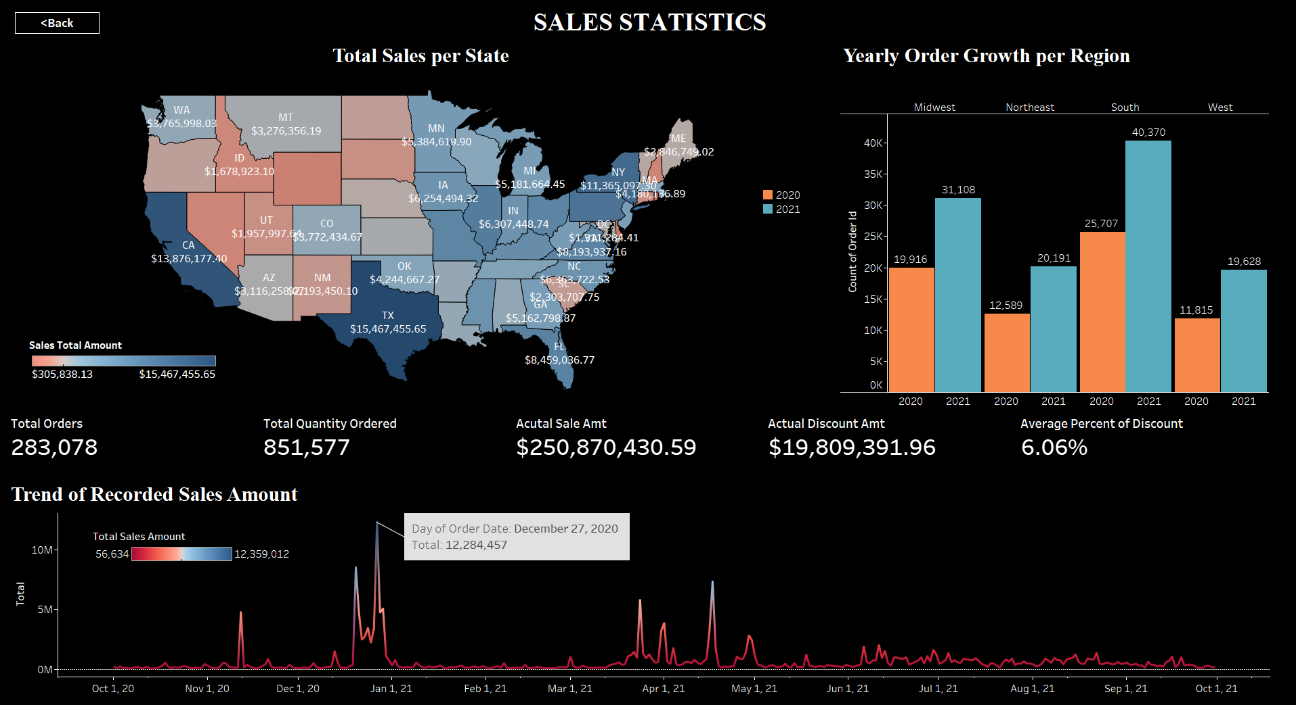

**Figure 24**

*After Drill Down*

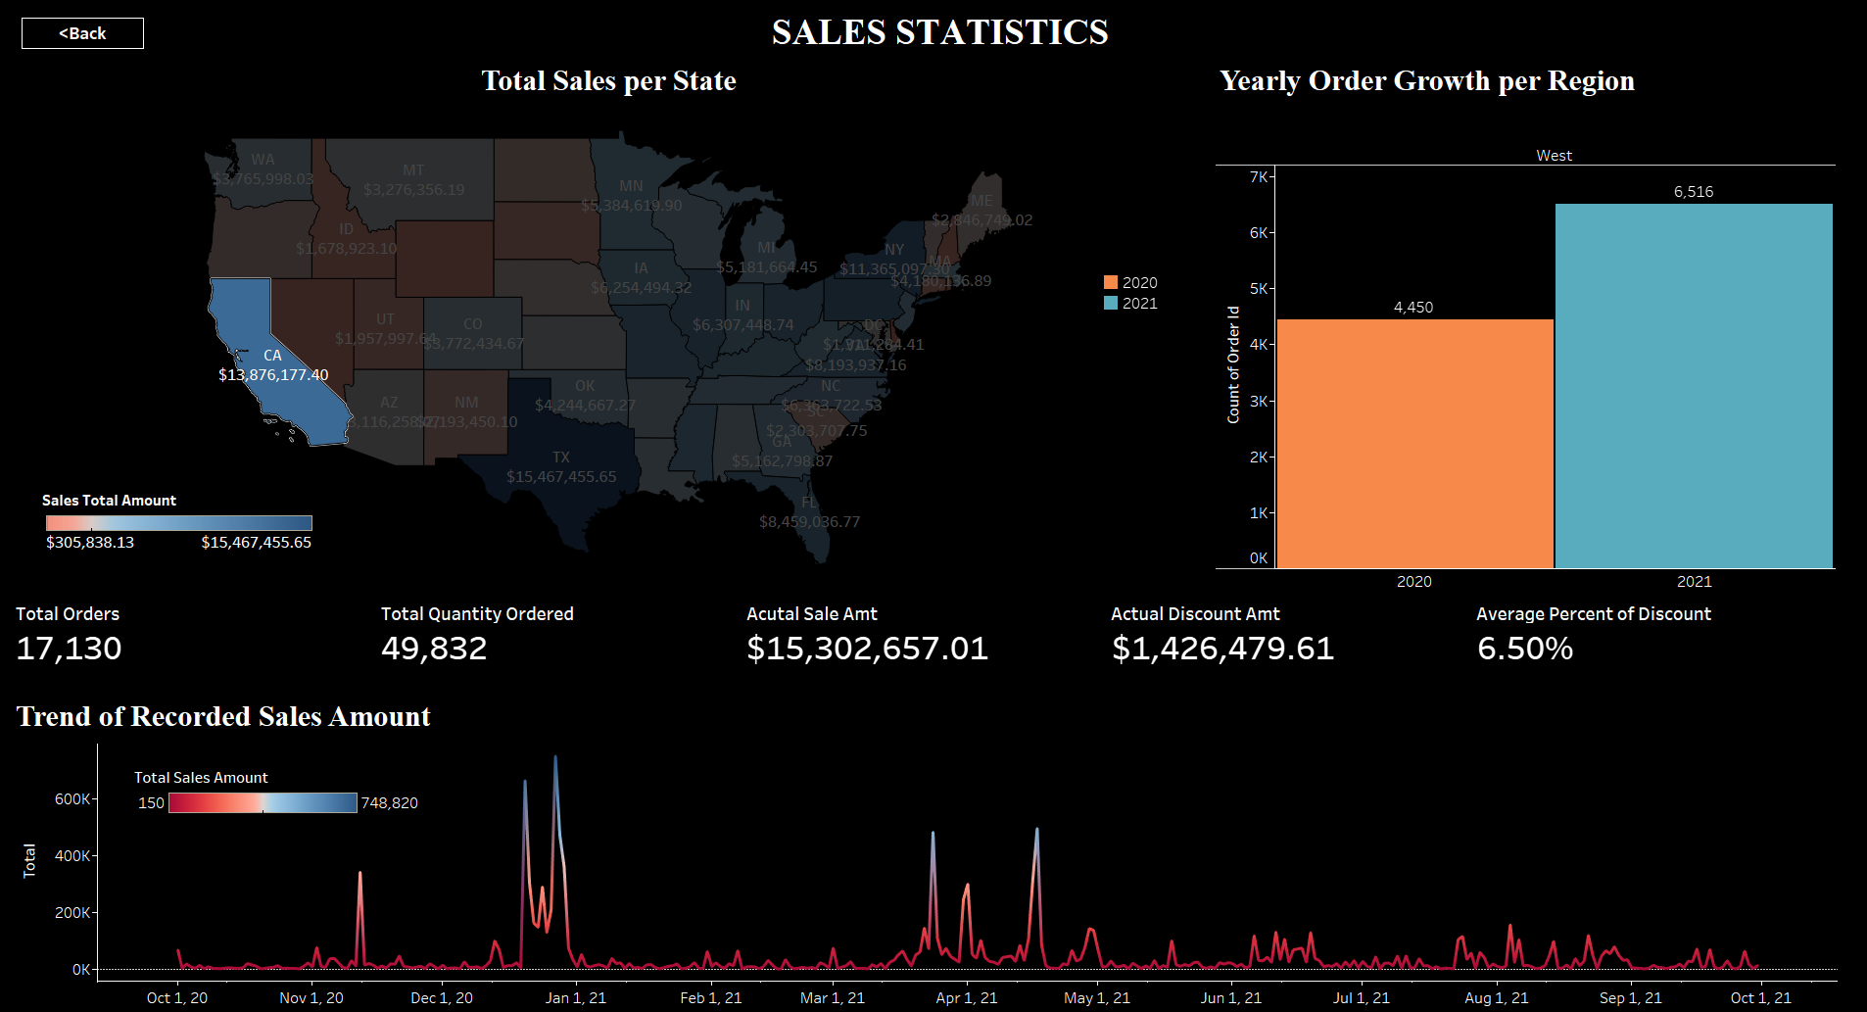

## 7.4 Selection

Selection controls were given to the user on the main page as well as in each of the dashboards. The homepage consist of 5 buttons each linked to the respective dashboard which constitute of the visualizations that cohesively give out a related story, The selection controls given the users are present as buttons, the buttons with links back to the home page was added to all the inner dashboards. The users can select and move across all the dashboards as required with just a click of the mouse. Figure 25 shows how the buttons were created and figure 26 shows how it looks after creation. Figure 57 shows a back button linked to the customer dashboard.

**Figure 25**

*Button Creation*

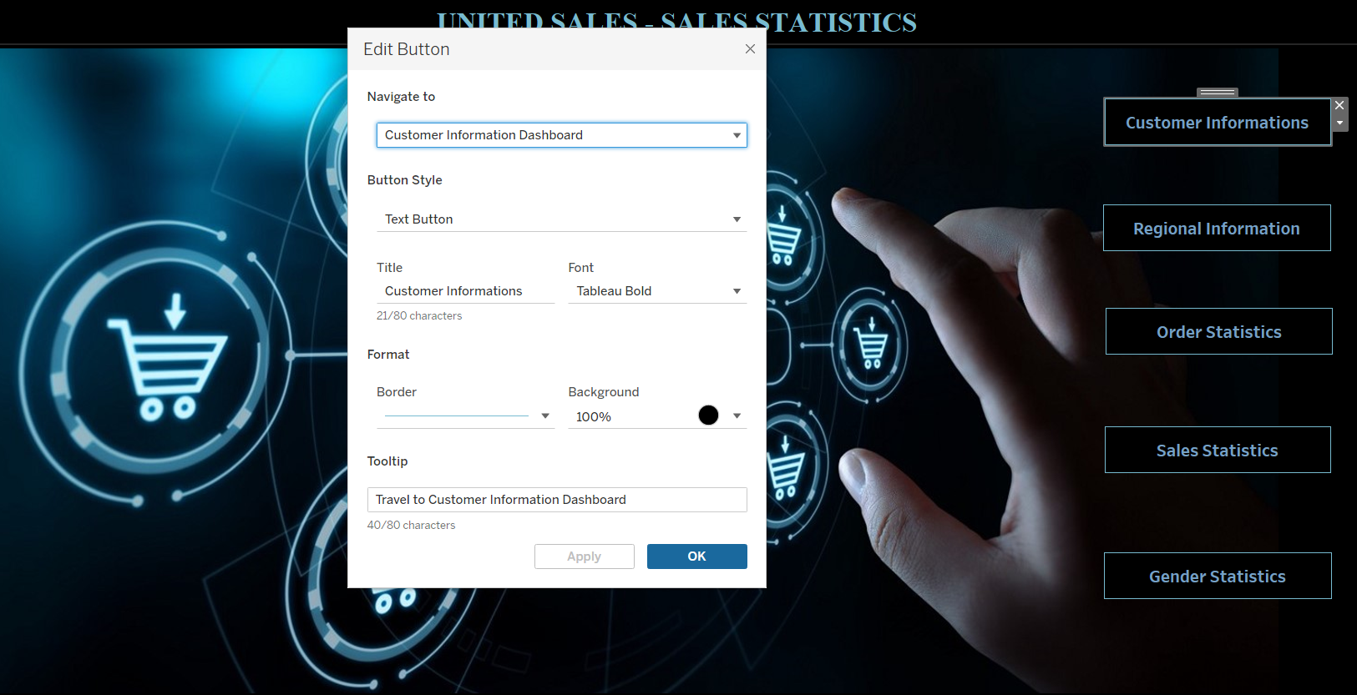

**Figure 26**

*Home Page with Buttons – Tool tip enabled*



**Figure 27**

*Back Button Presence within the Dashboard*

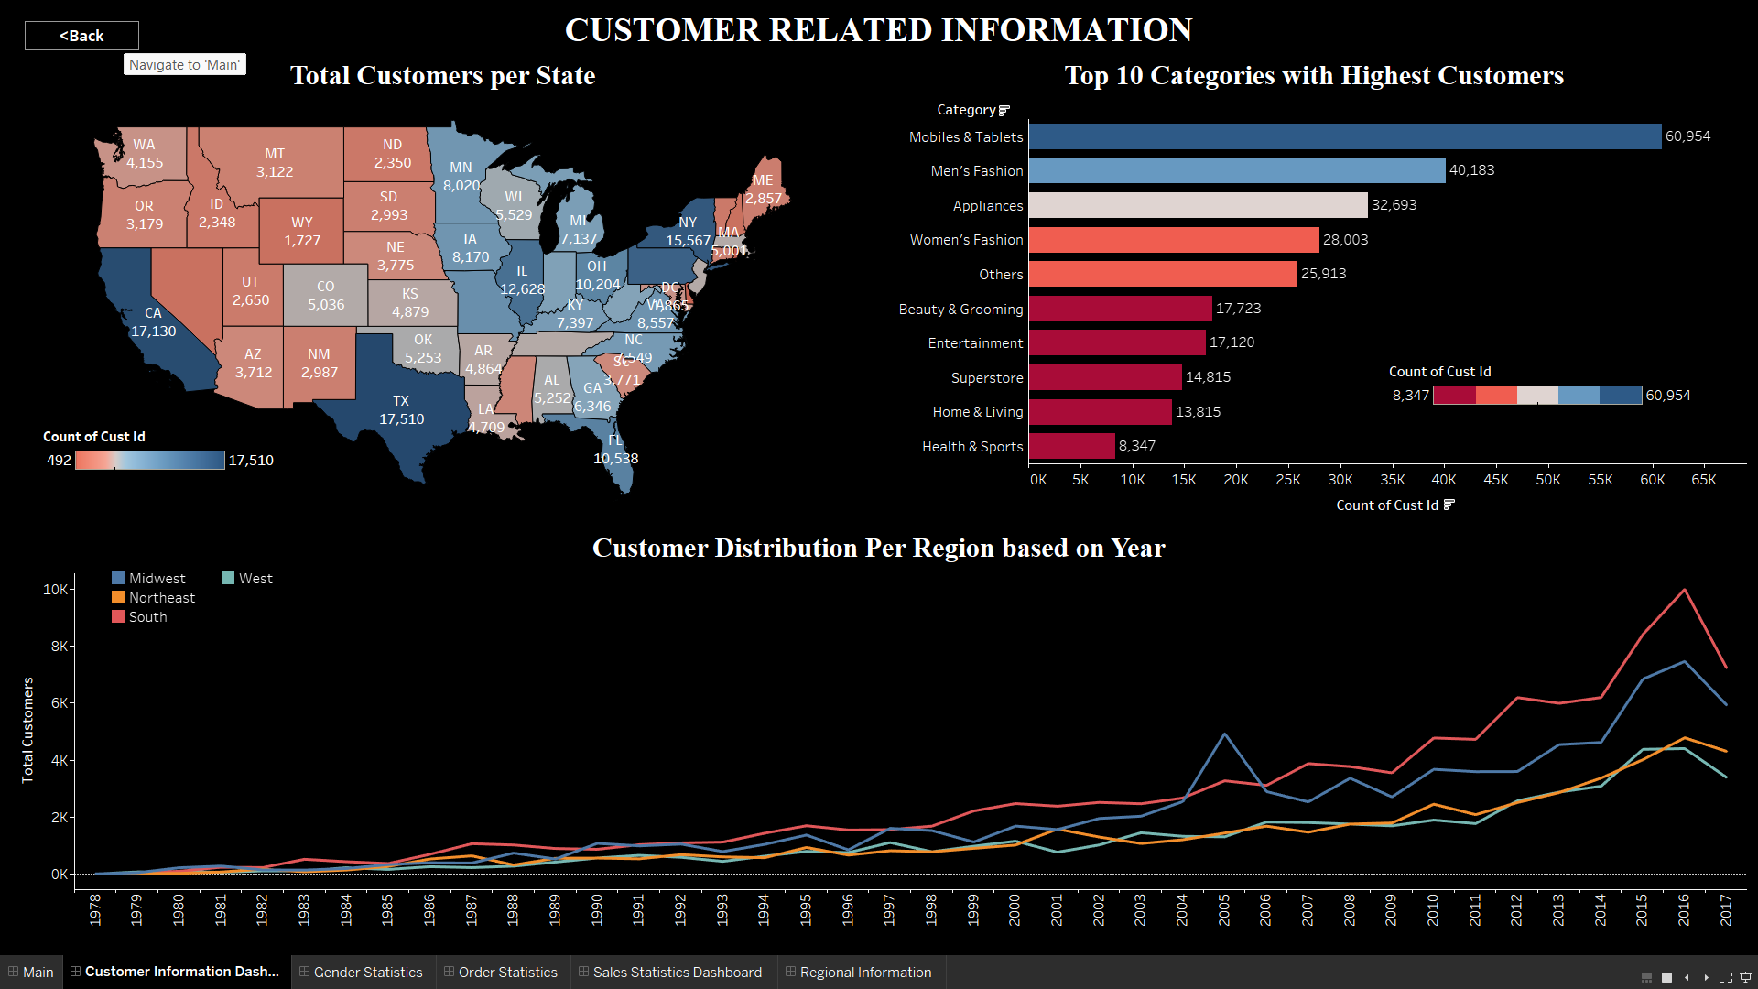

## 7.5 Overlays

The overlays were customized to suit the aesthetical choices that were followed throughout the project. The map layers were customized to produce a cohesive geo-spatial chart which depicts the necessary information in an easily readable format. Figure 28 shows the overlay configuration for a sample geo-spatial map used.

**Figure 28**

*Overlays – Geospatial Map Background Layers Customization*

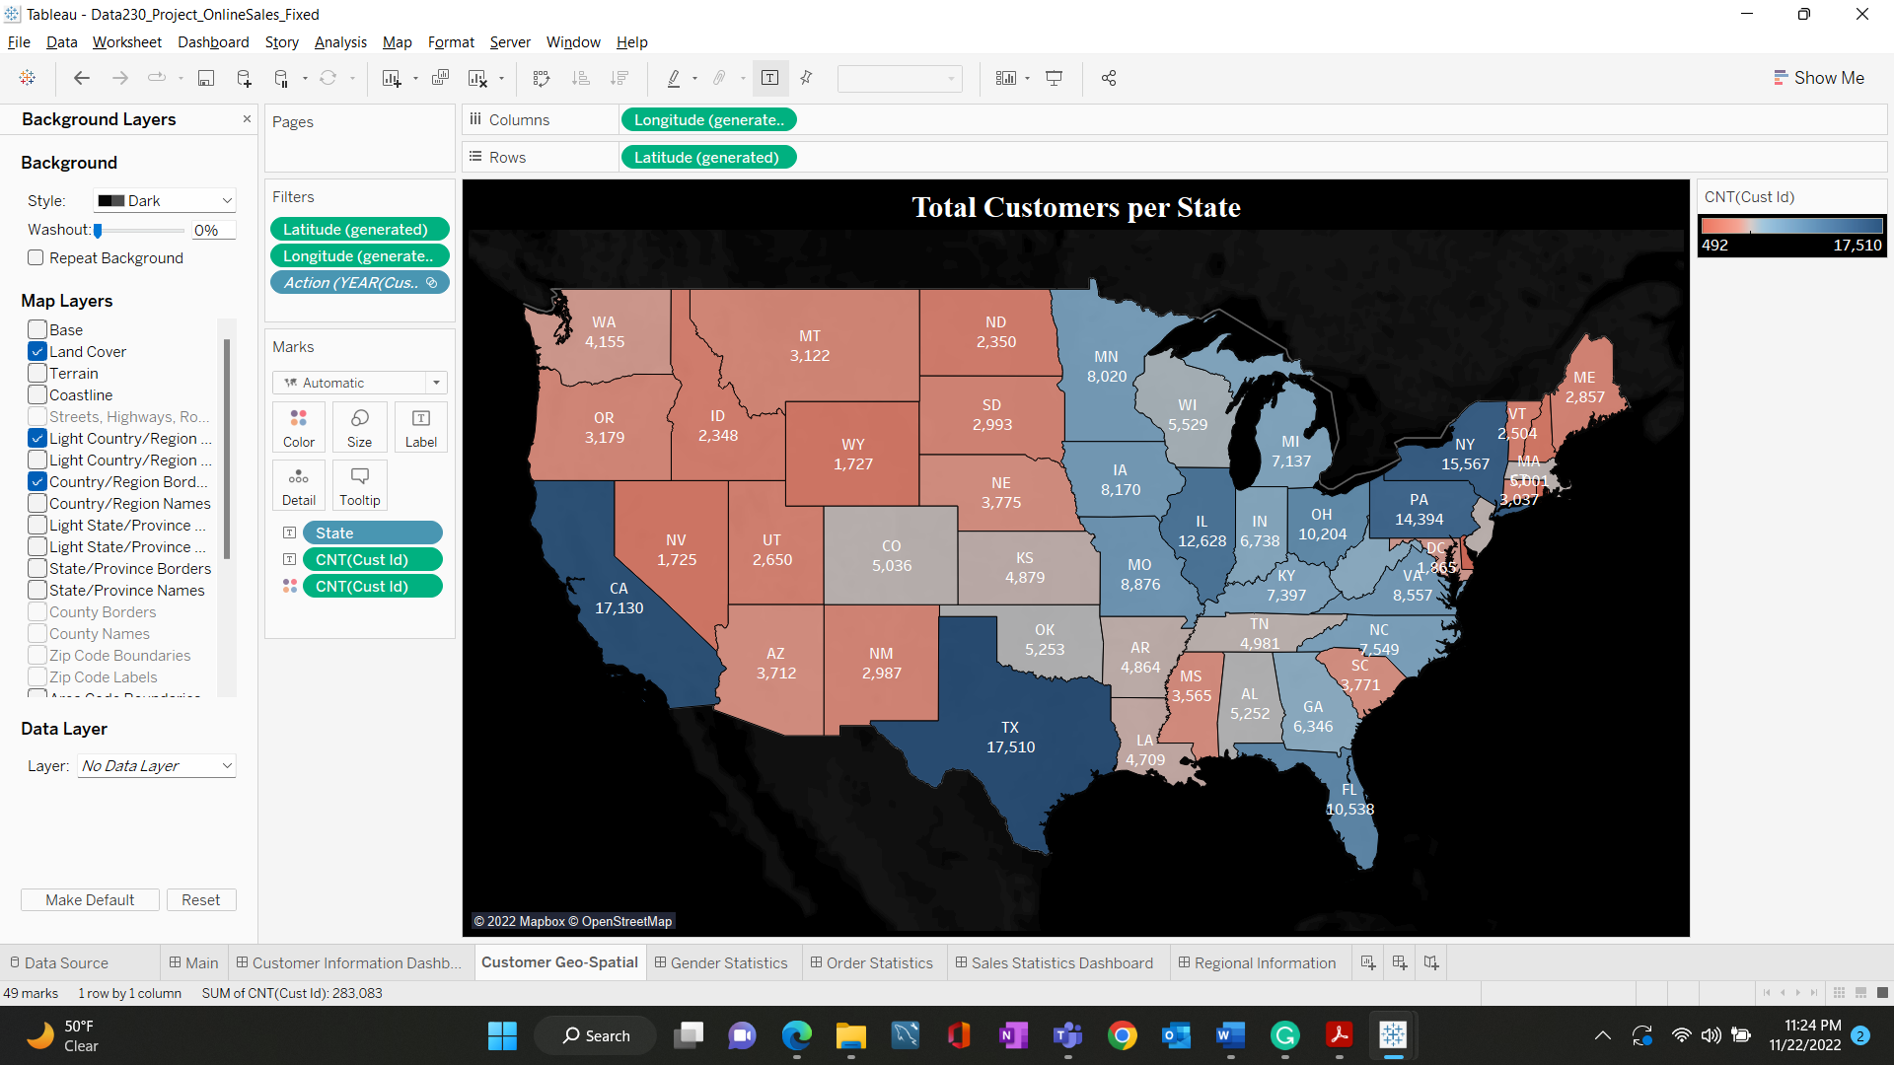

## 7.6 Storytelling

Story telling was included with the presence of a main home page. The story is weaved by enabling a click through button that traverses to another dashboard that gives the visualizations which tells a very specific story. For instance, the customer information dashboard contains charts that give out a story regarding the customer characteristics. Similarly figure 29 shows the buttons which just by name itself give an overview of what each dashboard is about.

**Figure 29**

*Buttons Created*

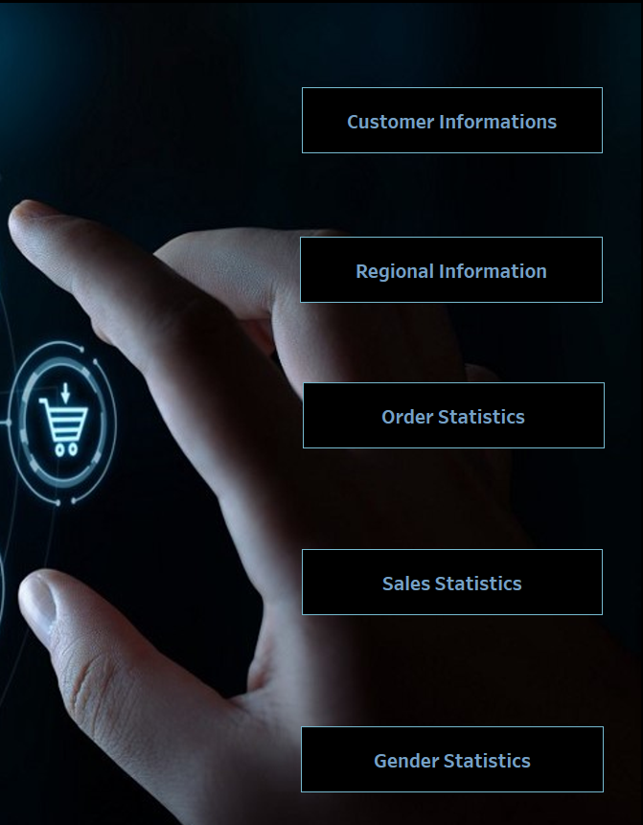

# User Interface Principles

This section discusses some of the principles that were adhered to while designing this project.

* Vocabulary opted through the project is standard and easily understandable
* The users are provided with the control through buttons to move from one dashboard to another with ease
* Drill down is also equipped with reverting back to original state by permitting the option to deselect the selection
* The visualizations are mostly straightforward and easily understandable since the vision from the initial stage was to keep it simple.
* Graphic design principle were adhered to while creation and the various principles followed were discussed in detail previously in this report
* Gestalt principled and Cognitive modeling were paid close attention to while designing
* The main point that was enforced all through the project is, the visualizations should rely most on recognition but not on recall. This was also followed throughout; at no point the user was needed to remember something for a longer period of time to understand the picture fully
* The project work is consistent throughout all the dashboard

# Overall Effectiveness

The overall effectiveness of the project can be measured by how well the project allows the users to interact with the visualizations and how understandable it is. The ease and comfort of the users was maintained as higher priority while designing this tableau workbook. The interactions make the report look more lively and the users are equipped with the power to pick and choose what kind of information they need and where to attain it from. The visualizations allow both top down and bottom up processing which helps with the information gain to progress more smoothly as required.

# Summary

Overall, the project can be summarized as an effort to minimize the customer workload and enable better data understanding with just few clicks. Some of the key points that were addressed during the tenure of this project are,

* Six Dashboards and 18+ individual worksheets were created.
* Nine different chart types were created
* 10 Buttons were created for ease of traversing across various dashboards
* All the principles that suit the project were adhered to while creation.
* The blank spaces were properly managed and aesthetically pleasing.
* Not more than 4 charts were placed per dashboard
* Proper headings and sub-heading typographical formulations were followed
* Key annotations were added whenever necessary
* Interactions were enabled wherever possible and more than 6 are uniquely identifiable.
* The color choices used were chosen to consider the visually impaired as well while keeping the aesthetical preferences in mind.
* Users were provided with control to pick and chosen whatever is needed.

**References**

Dataset Source Link: <https://www.kaggle.com/datasets/ytgangster/online-sales-in-usa>